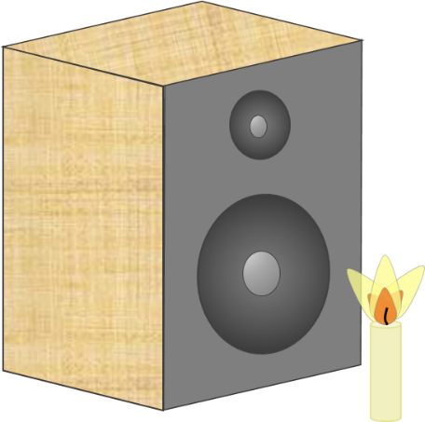
Candle in the sound

A lighted candle is put in front of a speaker
The speaker makes a sound wave.
The sound wave makes the candle flame flicker.

Predict
How will the candle flame move differently if the sound wave is made louder?

How will it move differently if the frequency of the sound wave is made higher?

Explain
Explain why you think this will happen.

Watch a demonstration of the investigation

Observe
Describe what happens to the candle flame when the sound wave is made louder, and when the frequency of the sound wave is increased.

Explain
Were your predictions and explanations correct?
Try to improve your first explanations to explain what happened more clearly.

Physics > Big idea PSL: Sound, light and waves > Topic PSL4: Waves > Key concept PSL4.2: A wave model of sound
Response activity
Candle in the sound

Overview
Learning focus: | As a sound wave (longitudinal wave) travels it transfers energy, as particles of the medium through which it travels are successively made to vibrate forwards and backwards along the direction in which the wave travels.
Observable learning outcome: | Compare the energy transferred by sound waves that have a different frequency or loudness to each other and are moving through a common medium.
Activity type: | Predict, explain; observe, explain (PEOE)
Key words: | Sound wave, vibrate, vibration, amplitude, frequency, energy

This activity can help develop students’ understanding by addressing the sticking-points revealed by the following diagnostic question:
- Diagnostic question: Sound bubble
What does the research say?
When waves move through a medium students often describe the movement of some entity (perhaps mass, matter or force) through the medium. The scientific explanation involves no such movement. A wave moves forwards when a perturbation passes through a medium, and after it has passed the material of the medium returns to its original position. This is what distinguishes the motion of a wave from the motion of an object. (Fazio et al., 2008)
In the study by Fazio et al. (2008), some students explained that waves set off with a bigger amplitude moved faster because they had been given more energy or more force. When talking about energy students tend to use science terms loosely: Driver et al. (1994) describe evidence from several researchers that students often confuse ideas of energy with ideas of force, work or power and may use the terms interchangeably. (Rogers, 2018) emphasises the importance of teachers modelling accurate use of science terms and advises giving students opportunities to practise using language precisely to help them develop an accurate model of what is happening.
Generally people think of energy as a substance, with flow and conservation analogous to that of matter. Although not scientifically correct this is considered an acceptable analogy (Millar, 2011). When explaining how energy is transferred, (Tracy, 2014) recommends that we focus on describing the processes and mechanisms involved. He suggests that trying to identify the ‘energy’ in each step is just a labelling exercise that can get in the way of a clear understanding of what is happening.
Ways to use this activity
Students should complete this activity in pairs or small groups, and the focus should be on the discussions. It is through the discussions that students can check their understanding and rehearse their explanations.
To begin, each group should discuss the activity and use their scientific understanding, firstly to predict what they think will happen, and then to explain why they think they are going to be right. If students in any group cannot agree, you may be able to direct them with some careful questioning.
Students now watch a demonstration of the investigation. If you have a class set of equipment for each group to carry out their own practical then you are very lucky, although the cacophony of sound likely to be created may deter you from this approach.
Practical-demonstration procedure
- Set up the loudspeaker to run from a signal generator.
- Without the candle demonstrate the movement of the speaker cone as the amplitude is increased, and then as the frequency is increased from zero, up to a frequency that can be heard. This is more dramatic if the speaker is placed on its side and a ping-pong ball (or several) placed in the cone.
- Light the candle and show how it flickers when placed in the sound wave. A very low frequency works best – perhaps just a few hertz, below what the students can hear. This gives a more distinct movement to the flame’s flicker. Don’t forget to start with a low amplitude too.
- Demonstrate the effect of increasing amplitude, and then of increasing frequency.
After the practical each group should be given the opportunity to change, or improve their explanation. A good way to review your students’ thinking might be through a structured class discussion. You could ask several groups for their explanations and put these on the whiteboard. Then ask other groups to suggest which explanation is the most accurate and the most clearly expressed, and through careful questioning work up a clear ‘class explanation’.
A useful follow up is for individual students to then write down explanations in their own words – without reference to the class explanation on the board (i.e. cover it up).
Differentiation
The quality of the discussions can be improved with a careful selection of groups; or by allocating specific roles to students in the each group. For example, you may choose to select a student with strong prior knowledge as a scribe, and forbid them from contributing any of their own answers. They may question the others and only write down what they have been told. This strategy encourages contributions from more members of each group.
Equipment
For the class:
- A loudspeaker
- A signal generator
- Connecting wires
- A candle, and the means of lighting it
- A support for the candle
- Ping-pong balls (3 or 4)

Technician notes
A large (bass) speaker works best, with any screen removed from in front of it so the cone is visible.
The candle needs to be securely fixed in place on a support so that the flame is roughly level with the centre of the speaker.
The position of the candle can be altered to maximise the effect, but 20 to 30 cm from the speaker usually works well.
Health and safety
Mains electricity and a hot candle.
Hot wax may drip if the candle is moved and may cause burning – more likely (?) if the demonstration is assisted or carried out by students.
Practical work should be carried out in accordance with local health and safety requirements, guidance from manufacturers and suppliers, and guidance available from CLEAPSS.
Expected answers
With a louder sound the size of the candle’s flicker increases. The air particles are moving backwards and forwards a greater distance and the candle flame moves with them. Each air particle has more energy because it is moving more quickly – each air particle moves a greater distance in the same amount of time as one in a quieter wave of the same frequency.
With a higher pitched sound, the candle flickers more rapidly. There are more compressions passing the candle each second. Each air particle has more energy because it is moving more quickly – the same distance each flicker, but more times each second.
Acknowledgments
Developed by Peter Fairhurst (UYSEG).
Images: Peter Fairhurst (UYSEG).
References
Driver, R., et al. (1994). Making Sense of Secondary Science: Research into Children's Ideas, London, UK: Routledge.
Fazio, C., et al. (2008). Modelling Mechanical Wave Propogation: Guidelines and experimentation of a teaching-learning sequence. International Journal of Science Education, 30:11, 1491-1530.
Millar, R. (2011). Energy. In Sang, D. (ed.) Teaching Secondary Physics. London: Hodder Education.
Rogers, B. (2018). The big ideas in physics and how to teach them, 1 edn Abingdon and New York: Routledge.
Tracy, C. (2014). Energy in the new curriculum: an opportunity for change. School Science Review, 96(354), 11.

